**User Guidance of Tier.me**

**Jian Wang, 2015.7.12**

1. Home Page

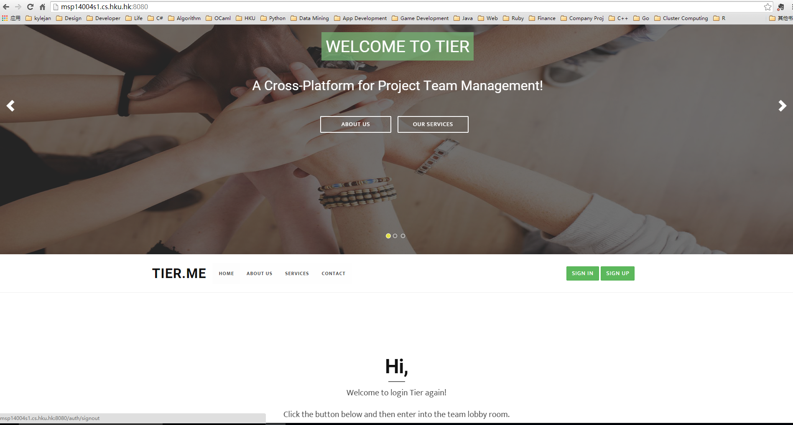

1. Click the Sign Up Button on the Home Page, then Register Your Account

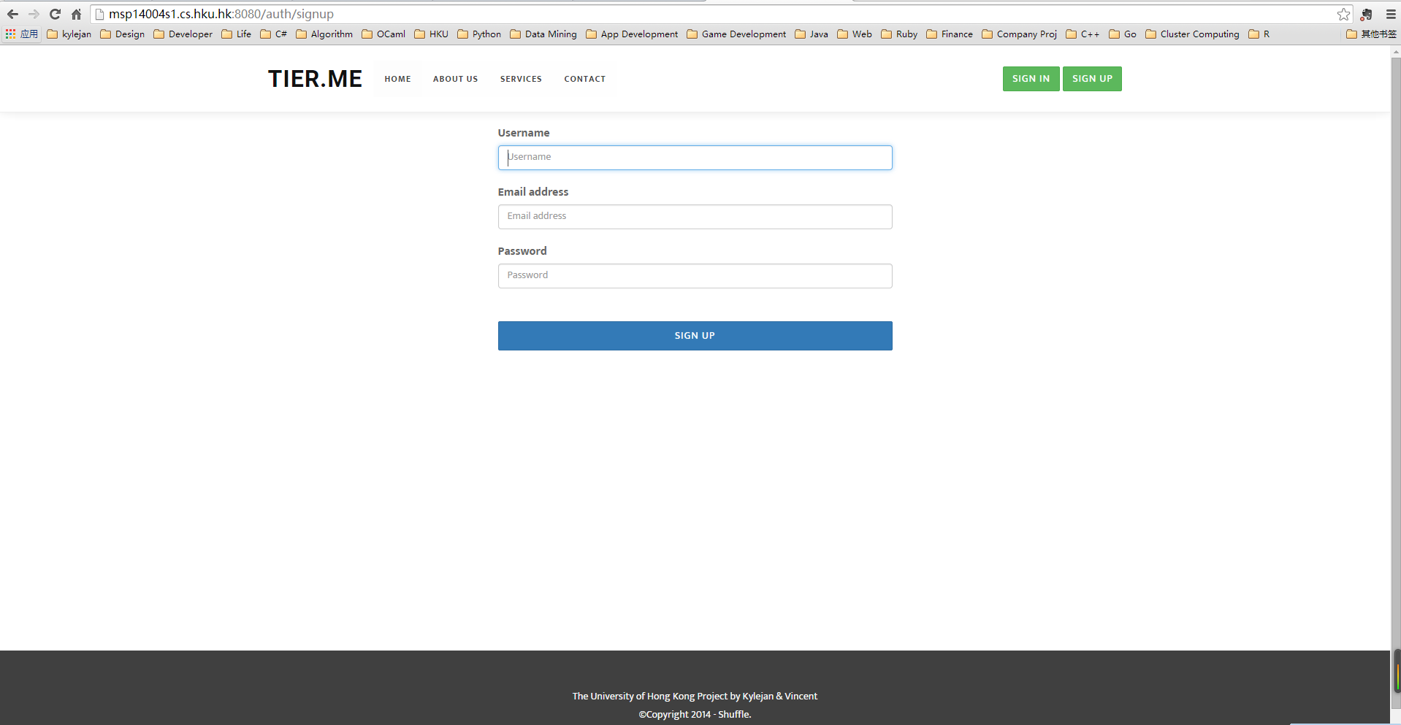

1. Click the Sign In Button on the Home Page, then Sign in your Account

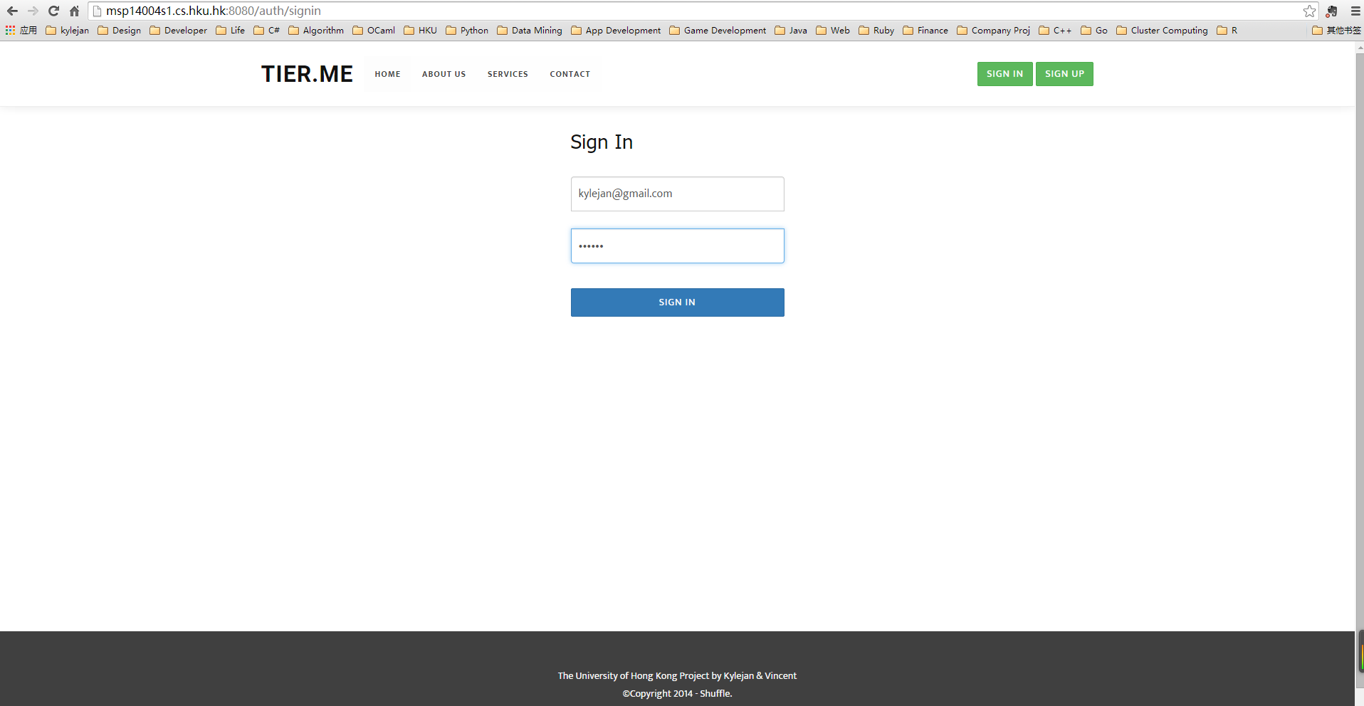

1. After Login Operation, Home Page will have a Start Button which is the entrance of User Dashboard

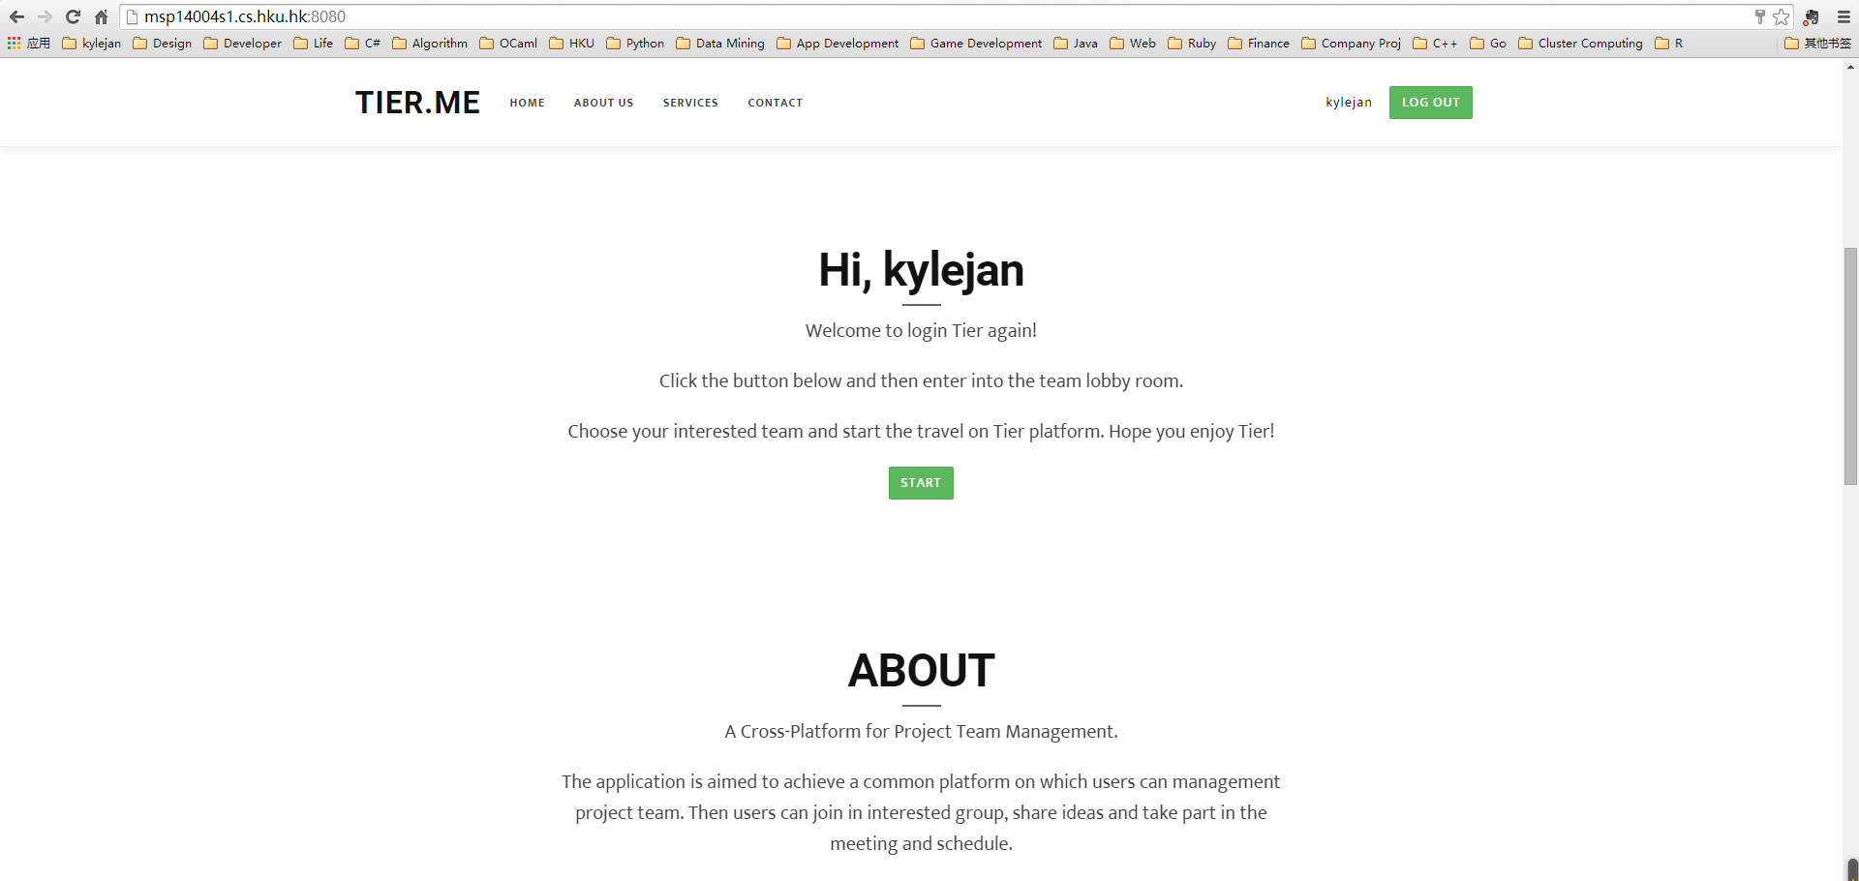

1. After Click the Start Button, a User Dashboard Page will be shown. It has three parts.

* Create a Team

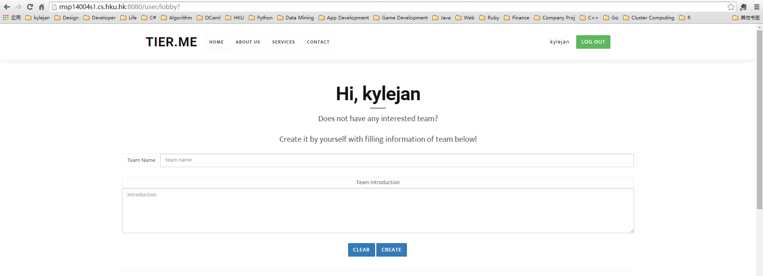

* Teams Joined

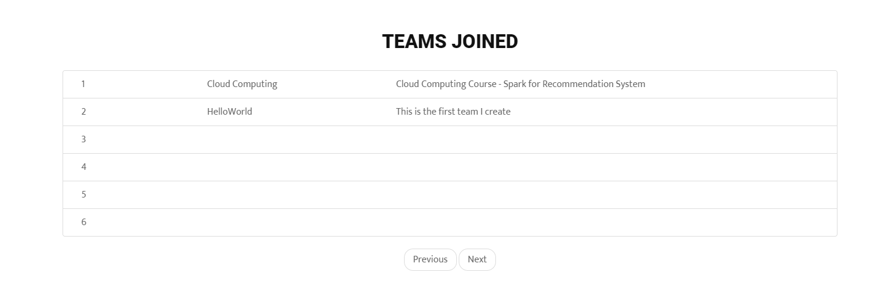

* Teams not joined

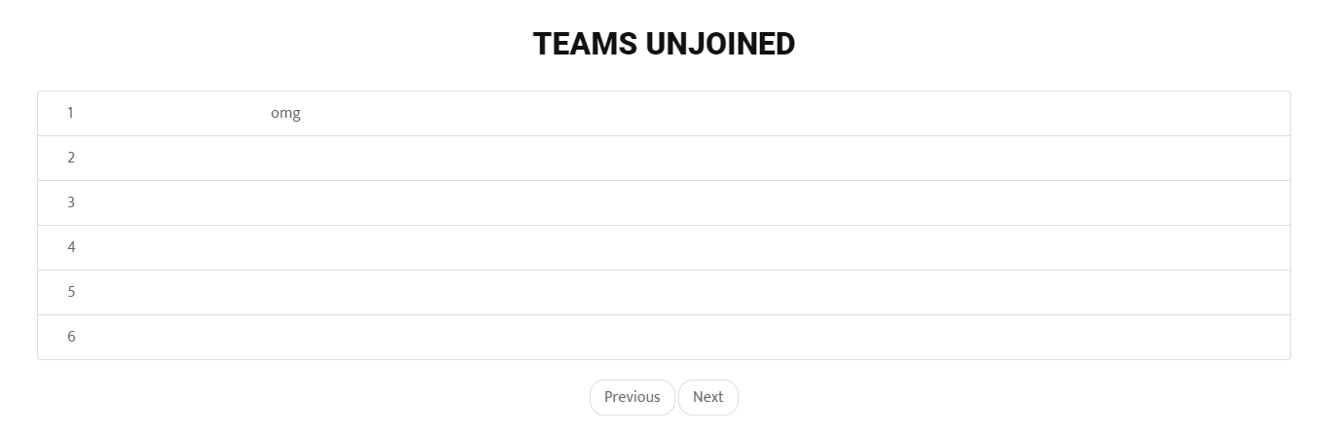

1. Click a specific team in which you are not joined, the home page of this team will be shown. And you can choose whether you want to join it. If you request to join in, the leader will receive your request and you have to wait for his acceptance.

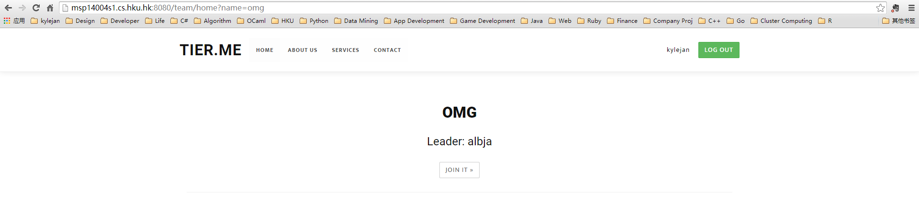

1. Click a specific team in which you have joined, the team dashboard will be shown.

There are several tab functions can be used by users in this team dashboard page.

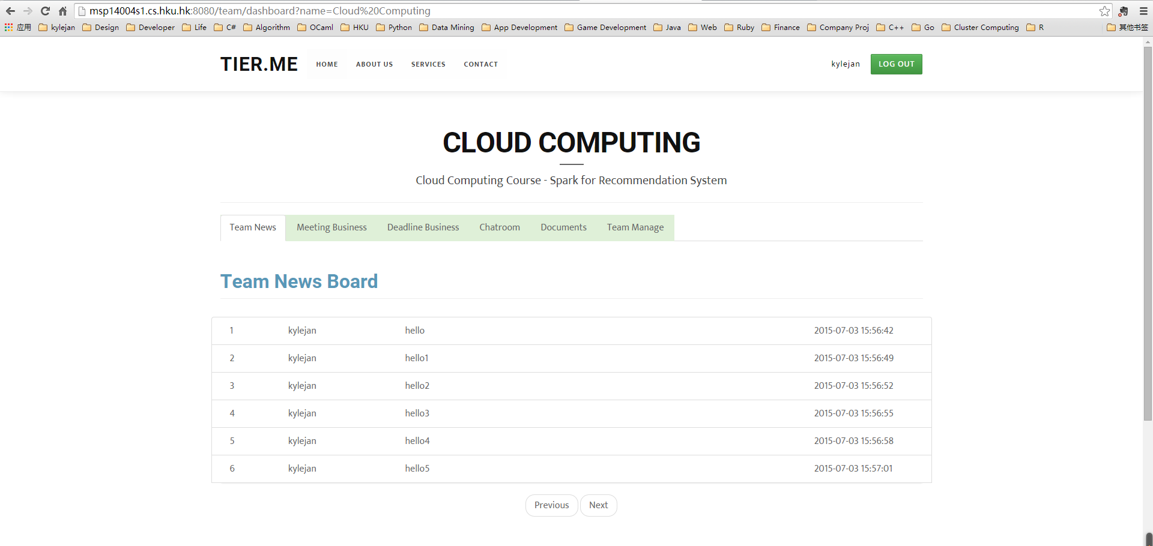

1. Team News Tab in Team Dashboard will show the team news in this team.

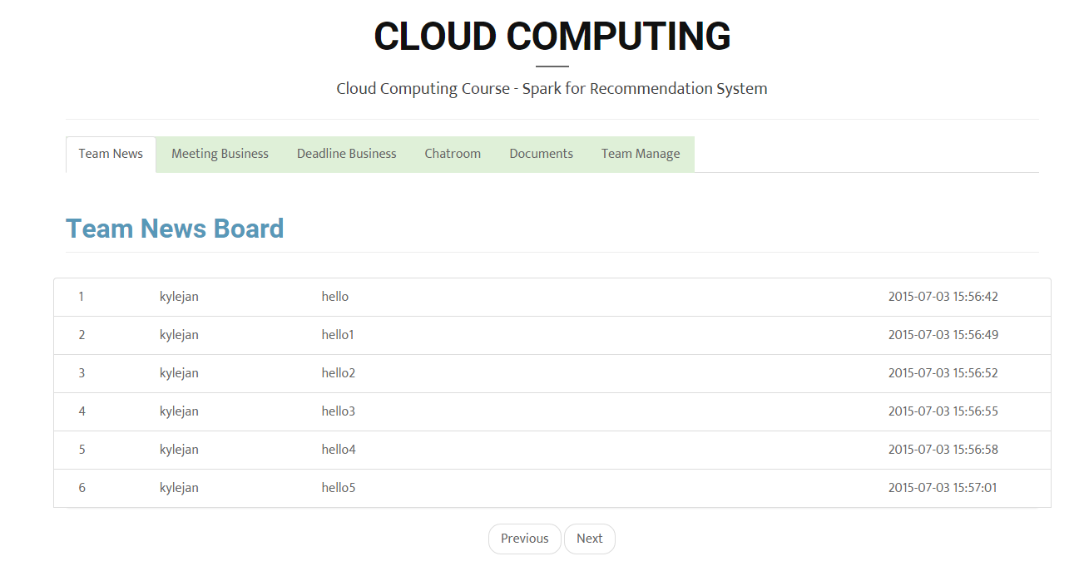

1. Meeting Tab in Team Dashboard will show the meeting schedule in this team.

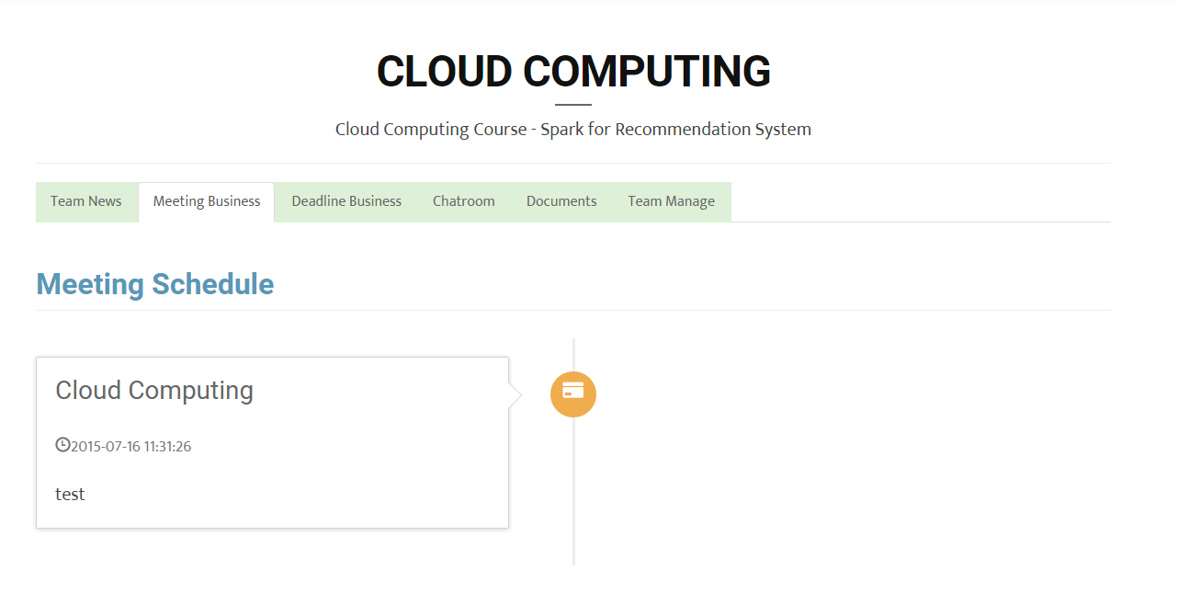

1. Deadline Tab in Team Dashboard will show the assignment deadline assigned to you in this team.

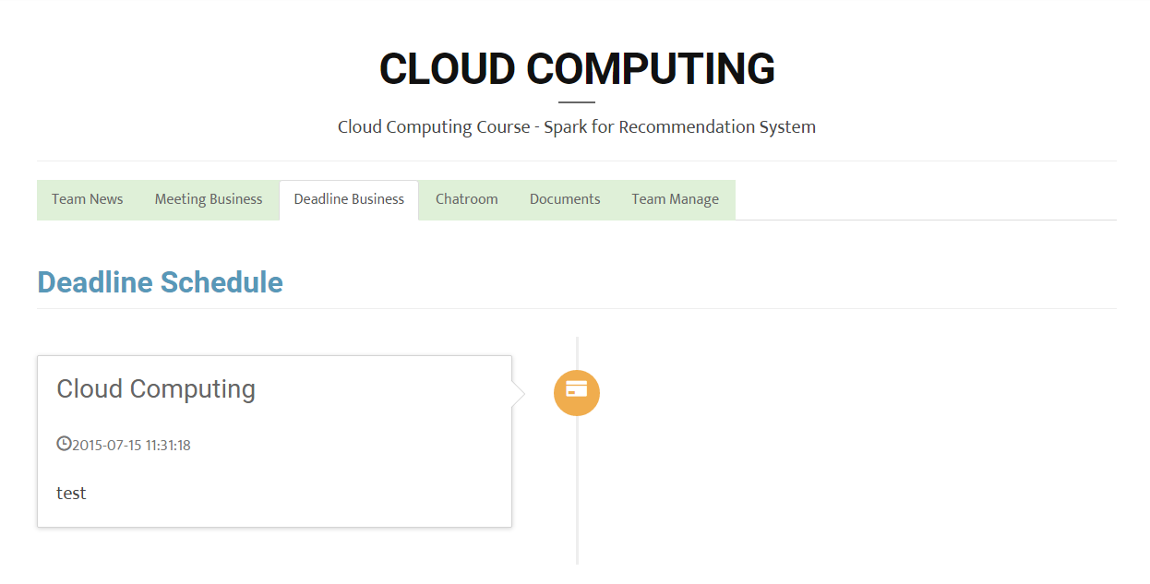

1. Team  Manage Tab in Team Dashboard have meeting creating function and assignment creating function.

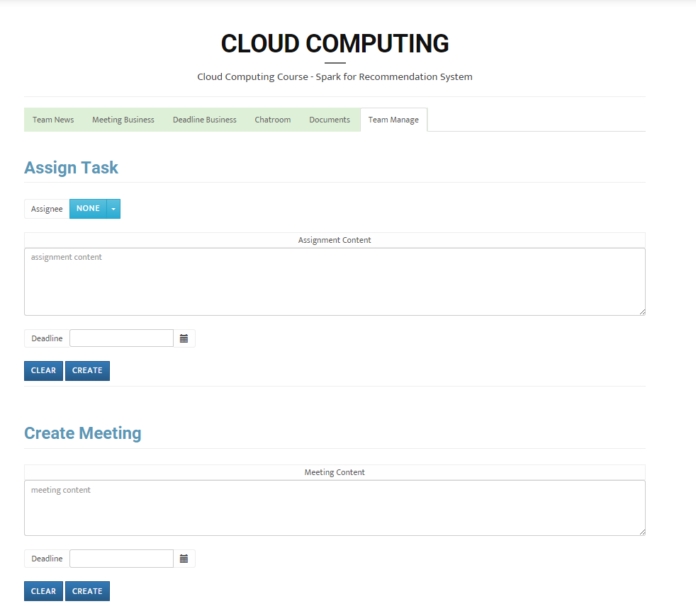

1. Document Tab in Team Dashboard allow user to create document and edit document simultaneously.

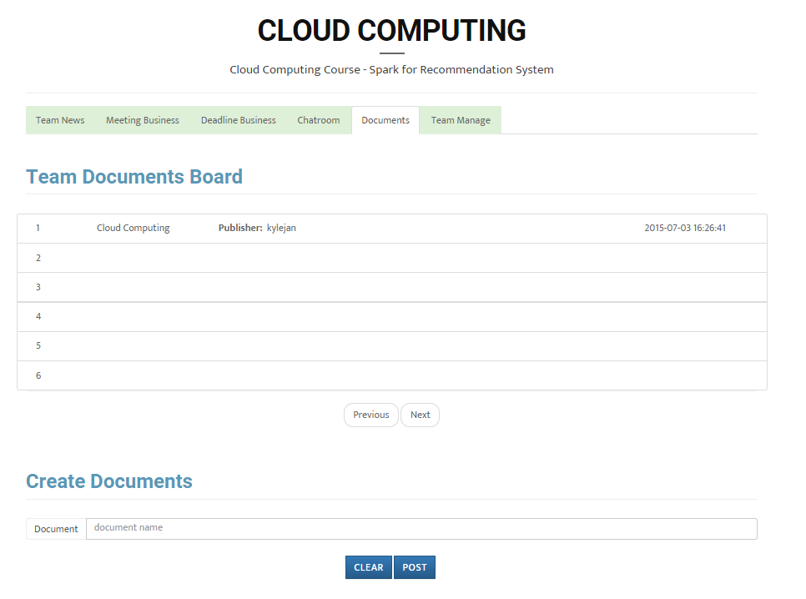

Click the created document, and then start your editing simultaneously.

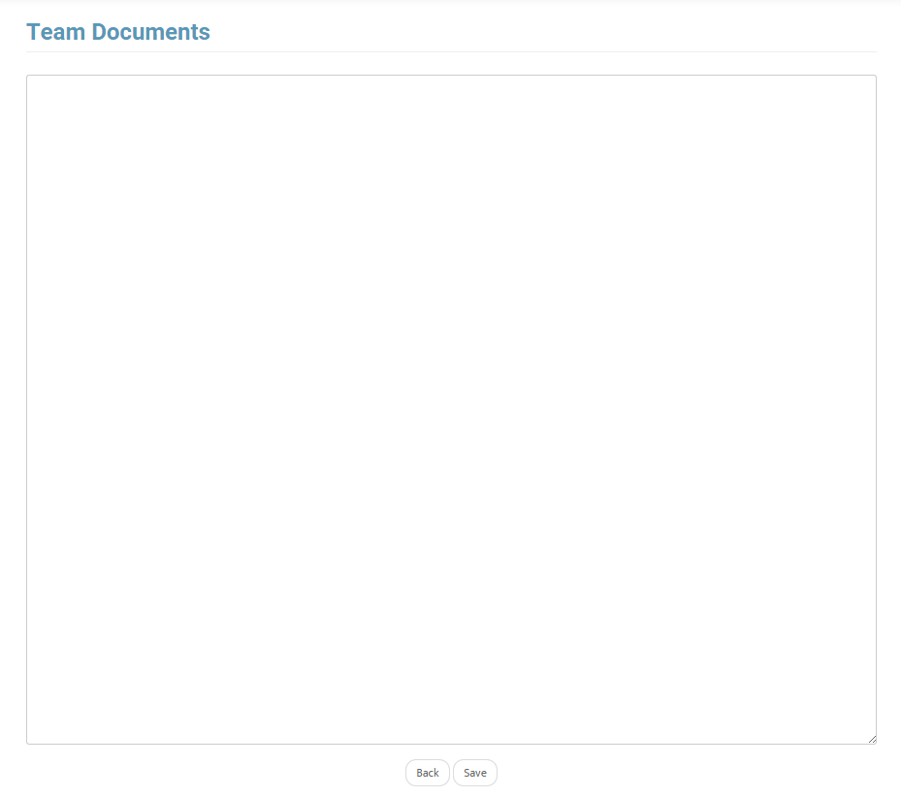

1. Chatroom Tab in Team Dashboard allow users to chat with each other on the platform

